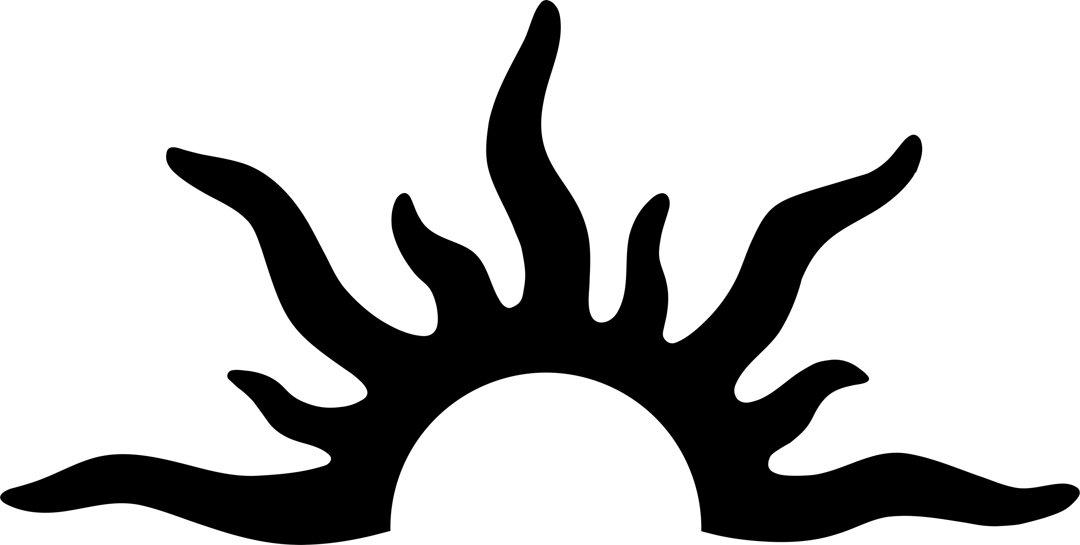
Vance Art Experiences
Art experiences that bring people together.

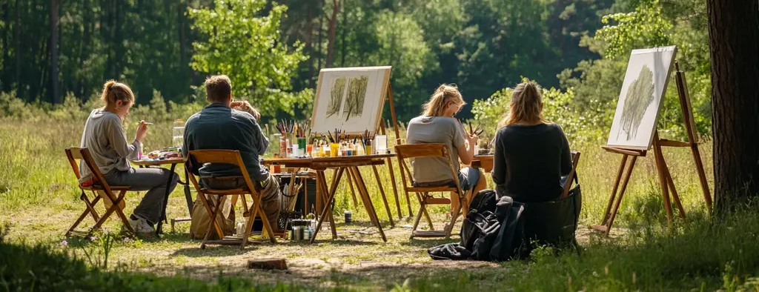

What you can Expect
Whether you are looking for a fun date night or meet a community of fellow artist. At Vance we offer art experiences that bring people together.
Our art experiences are designed to inspire both beginners and seasoned artists to relax, explore, and create in an inviting atmosphere. Whether you’re sharing a canvas with someone special, sketching from life, or enjoying the outdoors with fellow painters, every session offers the perfect balance of guidance, freedom, and fun. With all materials provided and step-by-step instruction, you’ll leave not just with artwork — but with memories and confidence that last long after the paint dries.

From intimate Couples Paint Nights that spark connection in the studio or under the open sky, to our lively Figure Drawing sessions that celebrate the human form, and the Plein-Air Painters Club, where nature becomes your muse — there’s an experience for every artist and every moment. Join us to unwind, learn, and share in the joy of creating art together.

Price List
Events | Cost | What’s Provided
Cupels Paint Night (studio) | $50.00 | All Materials (Paint, Canvas, Easel) Instruction, Refreshments
Cupels Paint Night (Outdoor) | $70.00 | All Materials (Paint, Canvas, Easel) Instruction, Refreshments
Figure Drawing (studio) | $15.00 | Model and Drawing Horse. (Drawing materials available for $3.00)
Plain-air Painters Club (Outdoor) | Free | No Materials or Instruction Provided

